**ASSIGNMENT 4**

**1.Odd String Difference**

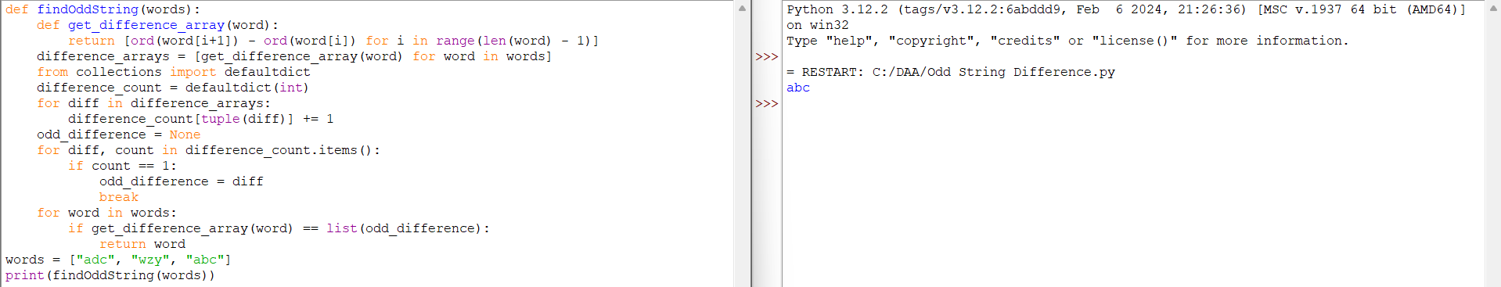

**2.Words within two Edits of Dictionary**

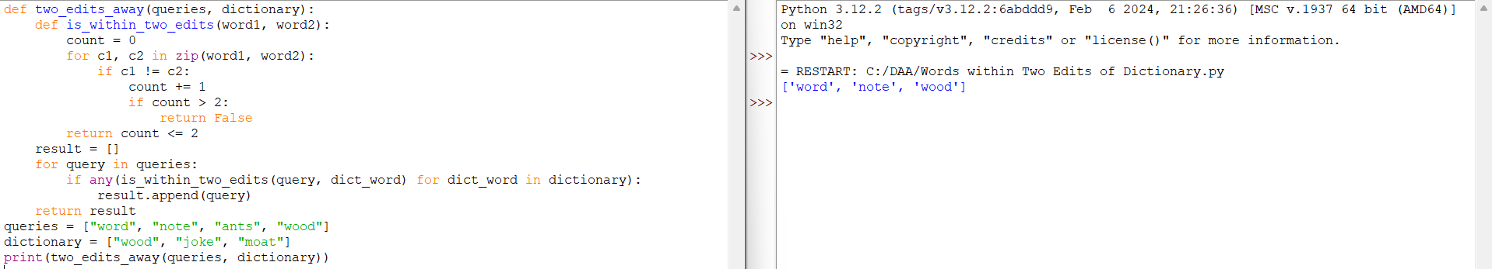

**3.Next Greater element IV**

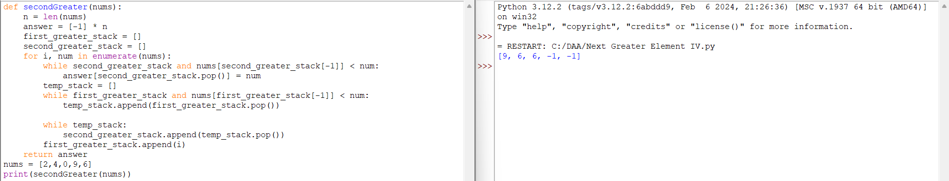

**4.Minimum Addition to Make Integer Beautiful**

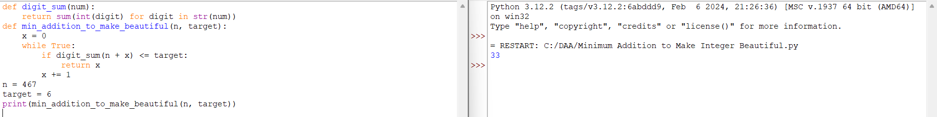

**5.Sort Array by Moving Items to Empty Space**

